FACULTY PROFILE
CHEMISTRY
DEPARTMENT:
DR. KHALID MUSTAFA SIDDIQUI
NAME:
DIGITAL PHOTOGRAPH:

DESIGNATION: | ASSISTANT PROFESSOR
DATE OF JOINING THIS COLLEGE: | 03-03-2008
TEACHING EXPERIENCE [at UG & PG level only]: | 12 Years & 6 Months at UG & PG level
CONTACT NO.: | 9835585039,8789671799
EMAIL ID: | ksid0157@gmail.com
ACADEMIC QUALIFICATIONS [PG & above only]: | M.Sc Chemistry, Ph.D, B.E.T
SPECIALIZATION/RESEARCH AREA: | Analytical Studies of Crystalline limestone of Hazaribagh District & to assess industrial utility & Genesis.
SUPERVISING RESEARCH SCHOLARS/ PURSUING RESEARCH:

RESEARCH PAPERS/ARTICLES: | 01
EDITED/AUTHORED BOOKS: | X
AFFILIATION/ASSOCIATION WITH JOURNALS, etc.: | X
MEMBERSHIP/ATTACHMENT WITH DIFFERENT ASSOCIATIONS/INSTITUTIONS/BODIES/BOARDS: | X
ACHIEVEMENTS/FELICITATIONS/AWARDS RECEIVED: | X
ANY OTHER RELEVANT INFORMATION: | X

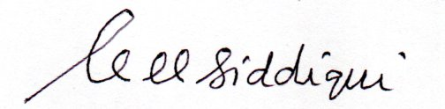
[SIGNATURE]

